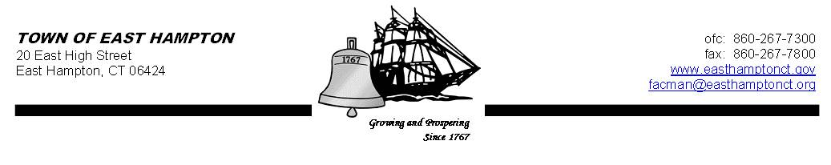

HIGH SCHOOL--ADDITION & RENOVATE-AS-NEW
HIGH SCHOOL BUILDING COMMITTEE MEETING
High School (Library)
15 North Maple Street, East Hampton, CT 06424

AGENDA
Wednesday, April 11, 2012, 6:00 p.m.

All items on this agenda are subject to possible action.

- Call to order – Town Clerk Sandy Wieleba

- Building Committee member introductions

- Election of Building Committee officers:
- Elect Chairperson
- Elect Vice Chairperson

- Set dates, times and place for regularly scheduled meetings

- Discuss NEASC Report

- Discuss list of facility needs

- Tour of the High School

- Discuss grant process timeline for RFQs and RFPs for Design Services

- Review and discuss RFQ for Architectural/Engineering Design Services

- Public Remarks

- Adjournment

cc: John Weichsel
Judy Golden
Kevin Reich
Frank Grzyb
Cathy Sirois (for posting)

